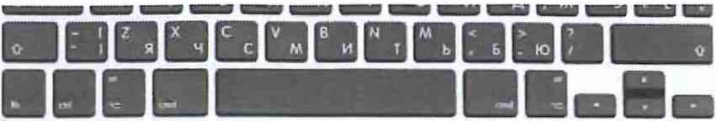

. >,
' ' ~
. .

I~

~. I=-..
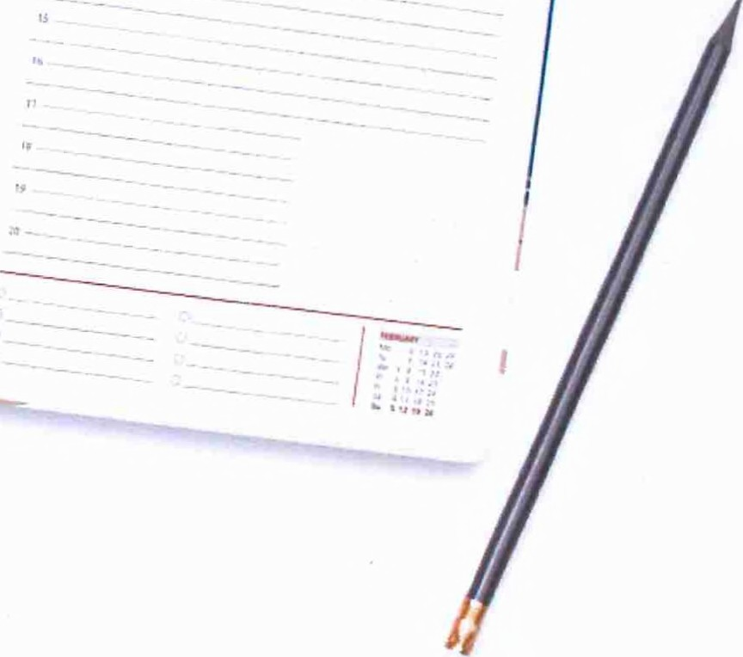.. ;,, ..

termo PU korica I thermo PU cover papir sarnoa I chamois paper 80 gsm dnevni planer I daily planner
dzep I pocket
~•
DIGITAL PRINTING

~

SCREEN PRINTING

~

Rokovnik I A enda
zaobljene ivice I rounded corners

FOIL STAMPING
R3055 A S 320 strana I pages
HOT STAMPING
* Available in English only

